2020 Business Plan Competition Award Summary

AWARDS

Edward K. Aldag Business Plan Competition Prizes
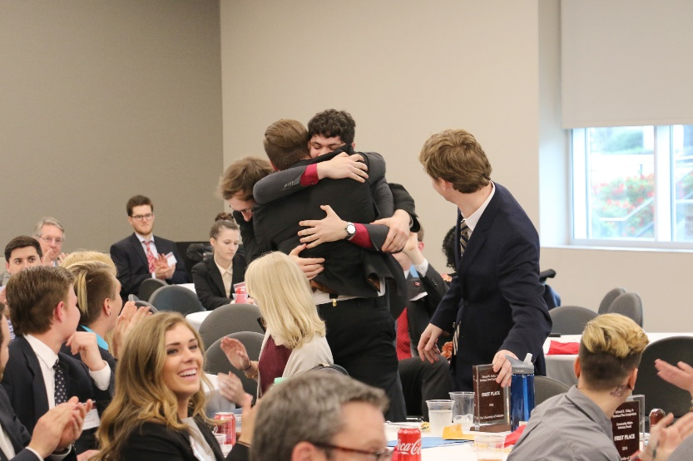
Learning, Winning and Teaming
Grand Prize of $50,000
The grand prize is awarded to a business (vs. an individual).

First Prize $5,000
Second Prize $3,000
Third Prize $2,000

Additional prizes of $500 each
- Best teamwork
- Best new idea
- Best social entrepreneurship idea
- Crowd favorite

Additional Prizes (provided to businesses)

Community Affairs Board of Directors Advisers Innovation and Entrepreneurship Award - $5,000

Office of Research and Economic Development Award - $2,500

Diversity Award - $1,500

ADDITIONAL AWARDS FOR ALL WINNERS

- One year of free co-working space at The EDGE
- Free consulting provided by accounting partners
- Free consulting provided by law firm partners
- Free business consulting
- Ability to apply to the summer 2020 Crimson Entrepreneurship Academy; this comes with a $3,500 stipend to work on your business full time and learn in the focused program run at The EDGE.
WHO’S ELIGIBLE

- Previous competitors (including 1st-prize and below) can compete with the same idea as long as they’ve made significant progress since the last year.
- Previous grand prize winners are unable to compete for the same idea again.
- A team may compete in the student track as long as they’re within 1 year of graduation.

